Servlet Listener 及 JSP Bean
1. 編輯C:\apache-tomcat-7.0.42\webapps\ROOT\WEB-INF\web.xml 加入
<context-param>
<param-name>catalogFileName</param-name>
<param-value>/WEB-INF/catalog.txt</param-value>
</context-param>
<listener>
<listener-class>domain.InitializeProductList</listener-class>
</listener>
<servlet>
<servlet-name>ShowProductListServlet</servlet-name>
<servlet-class>domain.ShowProductList</servlet-class>
</servlet>
<servlet-mapping>
<servlet-name>ShowProductListServlet</servlet-name>
<url-pattern>/catalog</url-pattern>
</servlet-mapping>

2. 建立資料類別Product.java程式並編譯:
package domain;
public class Product{
private String code;
private String price;
private int quantity;
private String description;
Product(String code,String price, int quantity, String description ) {
this.code=code;
this.price=price;
this.quantity=quantity;
this.description=description;
}
public String getCode() {
return code;
}
public String getPrice() {
return price;
}
public String getDescription() {
return description;
}
public int getQuantity() {
return quantity;
}
public void setCode(String code) {
this.code = code;
}
public void setDescription(String description) {
this.description = description;
}
public void setPrice(String price) {
this.price = price;
}
public void setQuantity(int quantity) {
this.quantity = quantity;
}
}
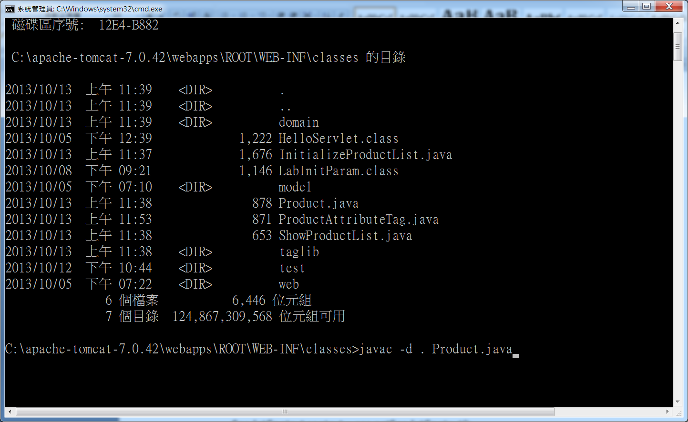
3. 建立物件初始監聽程式InitializeProductList.java程式並編譯:
package domain;
import javax.servlet.*;
import javax.servlet.http.*;
import java.io.*;
import java.util.*;
public class InitializeProductList implements ServletContextListener {
public void contextInitialized ( ServletContextEvent sce) {
ServletContext context = sce.getServletContext();
String catalogFileName =
context.getInitParameter("catalogFileName") ;
InputStream is = null;
BufferedReader catReader = null;
try {
is=context.getResourceAsStream(catalogFileName);
catReader = new BufferedReader(new InputStreamReader(is));
String ProductString;
ArrayList catalog = new ArrayList();
while ( (ProductString = catReader.readLine()) != null) {
StringTokenizer tokens =
new StringTokenizer(ProductString, "|");
String code=tokens.nextToken();
String price=tokens.nextToken();
String quantityStr=tokens.nextToken();
int quantity=Integer.parseInt(quantityStr);
String description=tokens.nextToken();
Product p=new Product(code, price, quantity, description);
catalog.add(p);
}
context.setAttribute("catalog", catalog);
context.log("The product list was initialized.");
} catch (Exception e) {
context.log("Parsing catalog.txt error!");
} finally {
if(is !=null) {
try {
is.close();
} catch (Exception e) {
e.printStackTrace();
}
}
if(catReader !=null) {
try {
catReader.close();
} catch (Exception e) {
e.printStackTrace();
}
}
}
}
public void contextDestroyed(ServletContextEvent sce) {}
}
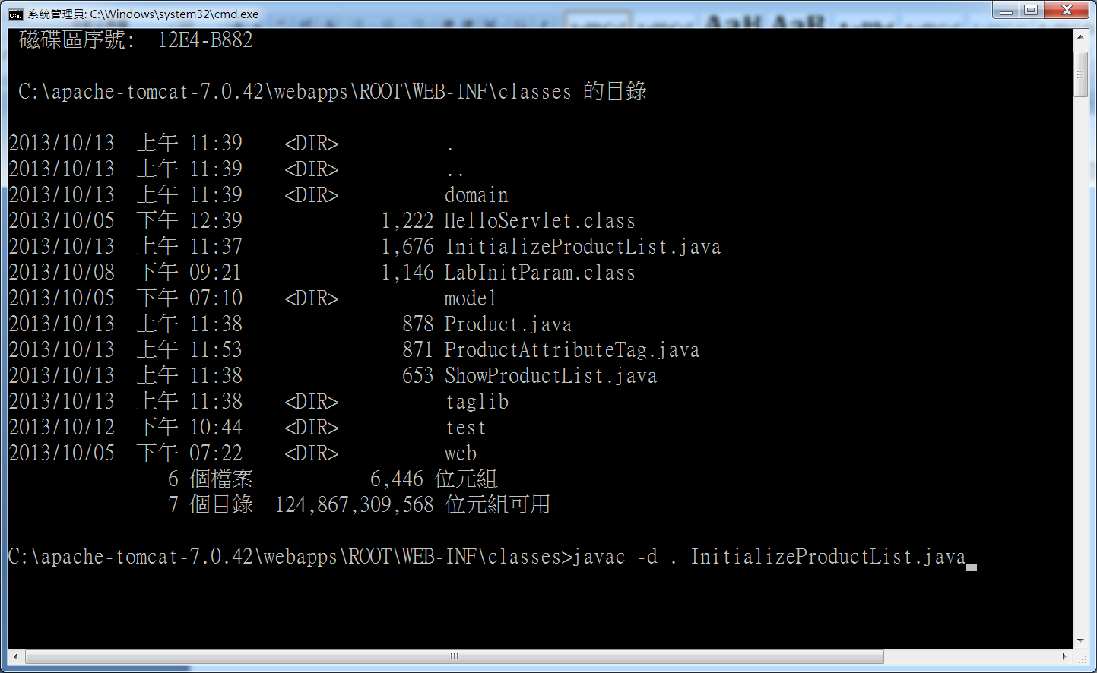
4. 建立MVC Controller類別ShowProductList.java程式並編譯:
package domain;
import javax.servlet.*;
import javax.servlet.http.*;
import java.util.*;
import java.io.*;
public class ShowProductList extends HttpServlet {
public void doGet(HttpServletRequest request, HttpServletResponse response) throws ServletException {
ServletContext context=getServletContext();
ArrayList list=(ArrayList )context.getAttribute("catalog");
request.setAttribute("catalog" , list);
RequestDispatcher forwardPage =
request.getRequestDispatcher("Show.jsp");
try {
forwardPage.forward(request , response);
} catch (IOException e) {
e.printStackTrace();
}
}
}
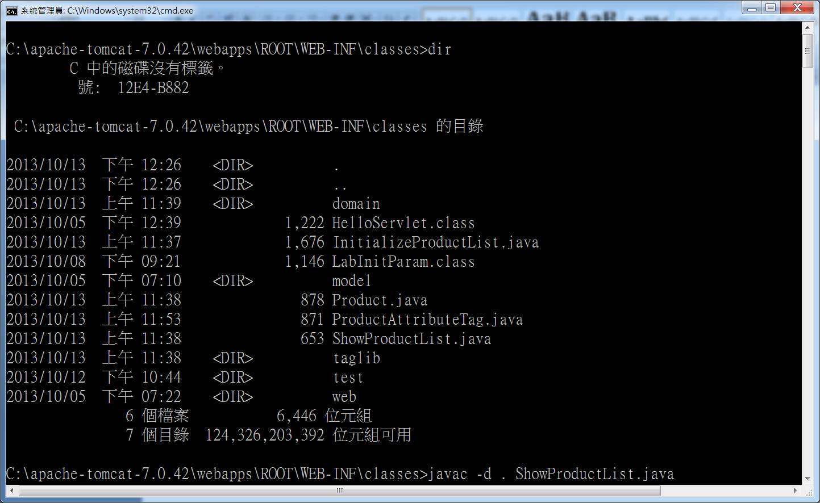
web pages內加入MVC View =>Show.jsp
jsp:useBean scope可以使用request 因為是透過ShowProductList的request.getRequestDispatcher("Show.jsp")轉向呼叫所以還在 request範圍內

<%@ page contentType="text/html; charset=UTF-8" %>
<%@ page import="java.util.*,java.io.*,domain.*" %>
<jsp:useBean id="catalog" scope="request" class="java.util.ArrayList" />
<%! Iterator itr = null; %>
<%
itr = catalog.iterator();
%>
<html>
<head></head>
<body>
<h1>MVC Listener & Beans</h1></br>
<span>DukeStore MVC-version</span>
<table border="1">
<tr>
<th>Code</th><th>Price</th>
<th>Description</th><th>Quantity</th>
</tr>
<% while (itr.hasNext()) {
Product prod = (Product)itr.next(); %>
<tr>
<td><%=prod.getCode()%></td>
<td><%=prod.getPrice()%></td>
<td><%=prod.getDescription()%></td>
<td><%=prod.getQuantity()%></td>
</tr>
<% } %>
</table>
</body>
</html>
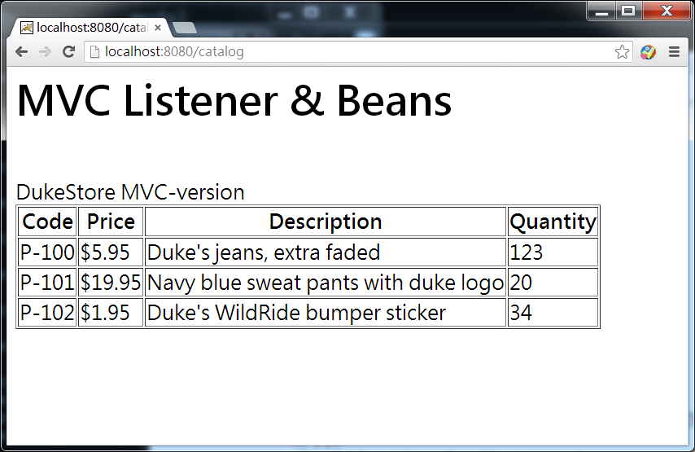

NetBeans 建立Servlet Listener 及 JSP Bean
